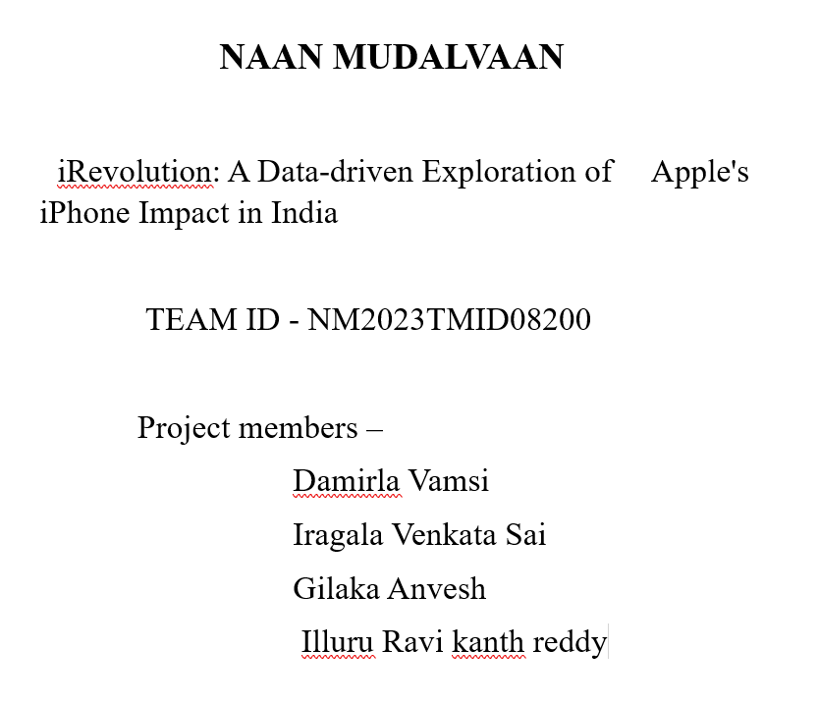

**1.INTRODUCTION**

**1.1 PROJECT OVERVIEW**

The report delves into the market share of Apples iPhone in India, comparing it with other smart phone brands. It explores the growth trajectory of the iPhone and its position in the highly competitive Indian market. The Study explores the economic implications of the iPhones presence in India. It examines the contribution of Apples operations to the Indian economy ,including, job creation, investments , and tax revenues

**1.2 PURPOSE**

The purpose of iRevolution is to provide a comprehensive analysis of the impact of Apple's iPhone in the Indian market, focusing on data-driven insights. The study aims to examine various aspects such as market share, consumer behavior, economic implications, local manufacturing initiatives, app ecosystem growth, challenges, and opportunities. By providing valuable insights and recommendations, iRevolution helps stakeholders, industry experts, and policymakers understand the current state of affairs and develop strategies for the future in the Indian smartphone market.

2. **LITERATURE SURVEY**

* 1. **Existing problem**

iRevolution aims to provide a comprehensive analysis of the impact of Apple's iPhone in the Indian market, focusing on data-driven insights. The study will examine various aspects such as market share, consumer behavior, economic implications, local manufacturing initiatives, app ecosystem growth, challenges, and opportunities. However, the existing problem for iRevolution is the lack of available data and comprehensive research on Apple's iPhone impact in India. This poses a challenge in providing accurate and reliable insights for stakeholders, industry experts, and policymakers. Therefore, iRevolution will need to collect and analyze relevant data to address this problem and provide a thorough understanding of Apple's iPhone impact in the Indian market.

**2.2 Problem statement & definition**

iRevolution aims to conduct a comprehensive analysis of the impact of Apple's iPhone in the Indian market, using data-driven insights. This study will examine various aspects such as market share, consumer behavior, economic implications, local manufacturing initiatives, app ecosystem growth, challenges, and opportunities. However, the lack of available data and comprehensive research on this topic poses a challenge for iRevolution in providing accurate and reliable insights for stakeholders, industry experts, and policymakers. Therefore, the main problem statement for iRevolution is to address this data gap and provide a thorough understanding of Apple's iPhone impact in the Indian market through data-driven research**.**

**3**. **IDEATION & PROPOSED SOLUTION**

**3.1 Empathy Map Canvas**

User's feelings towards iPhones and their impact in India User's thoughts and concerns about the affordability of iPhones in India User's experiences and challenges in accessing and using iPhone apps and services User's perception of Apple's marketing strategies and their influence on iPhone adoption in India. User's perceptions and experiences of the impact of iPhone usage on digital literacy and access to information in rural areas of India User's opinions and experiences regarding the impact of iPhone manufacturing and assembly units on local employment and the economy in India

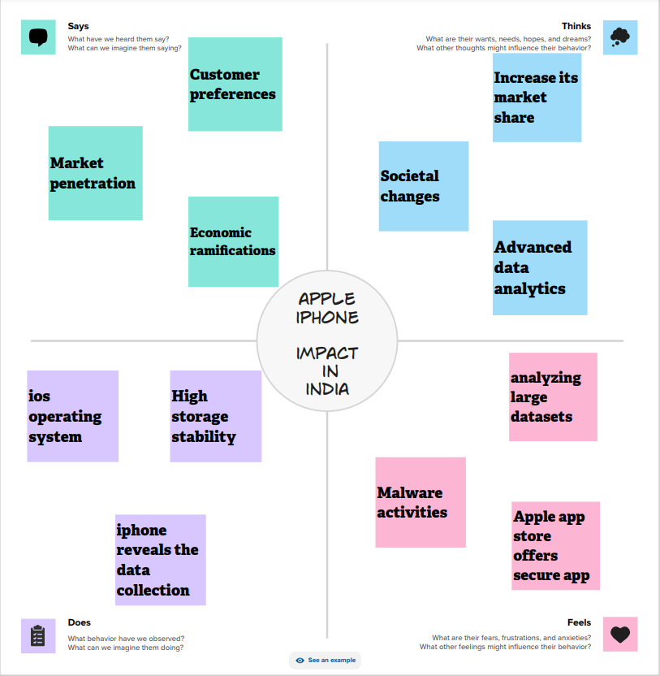

**3.2 Ideation & Brainstorming**

Analyzing the growth of iPhone sales in India over the years and its impact on the overall smartphone market.Investigating the impact of iPhone usage on digital literacy, internet penetration, and access to information in rural areas of India

**STEP – 1 : Team Gathering, Collaboration and Select the Problem Statement**

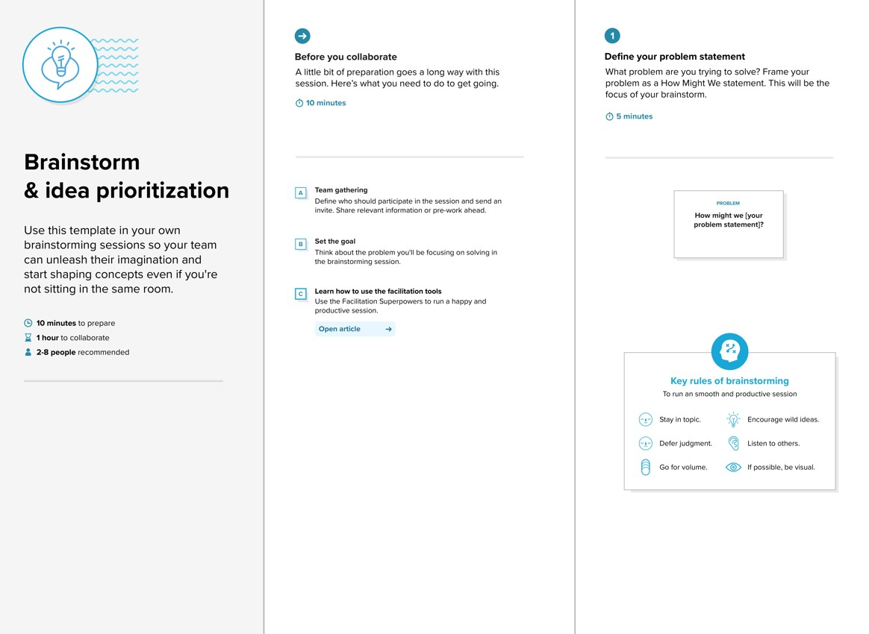

**STEP -2 :Brainstorm, Idea Listing and Grouping**

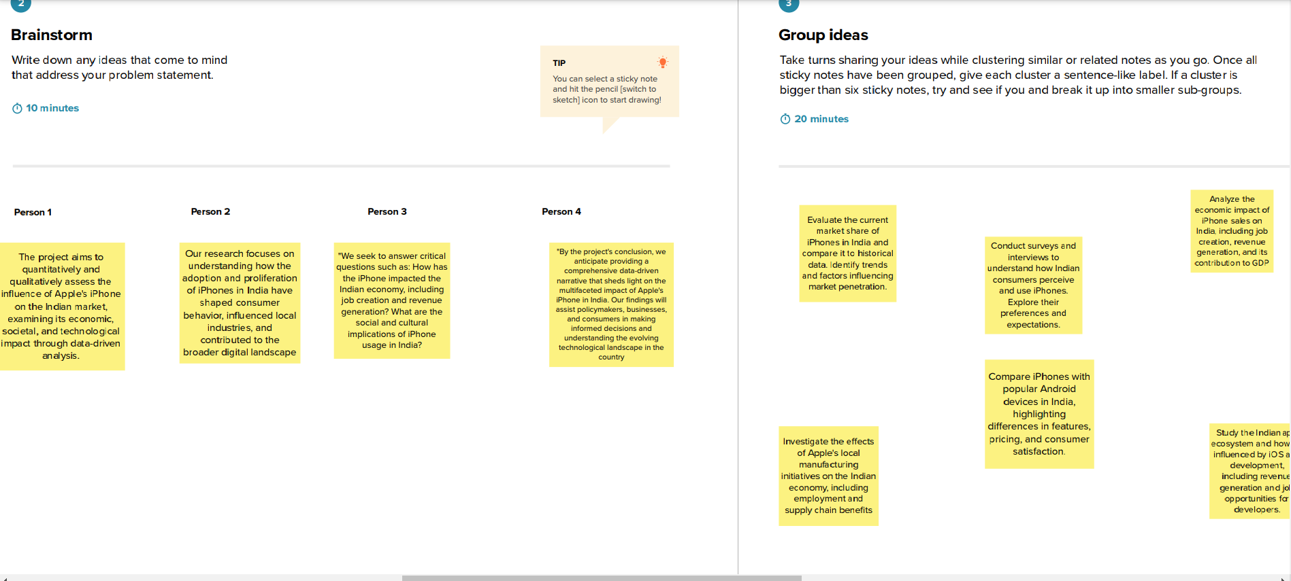

**STEP -3 : Idea Prioritization**

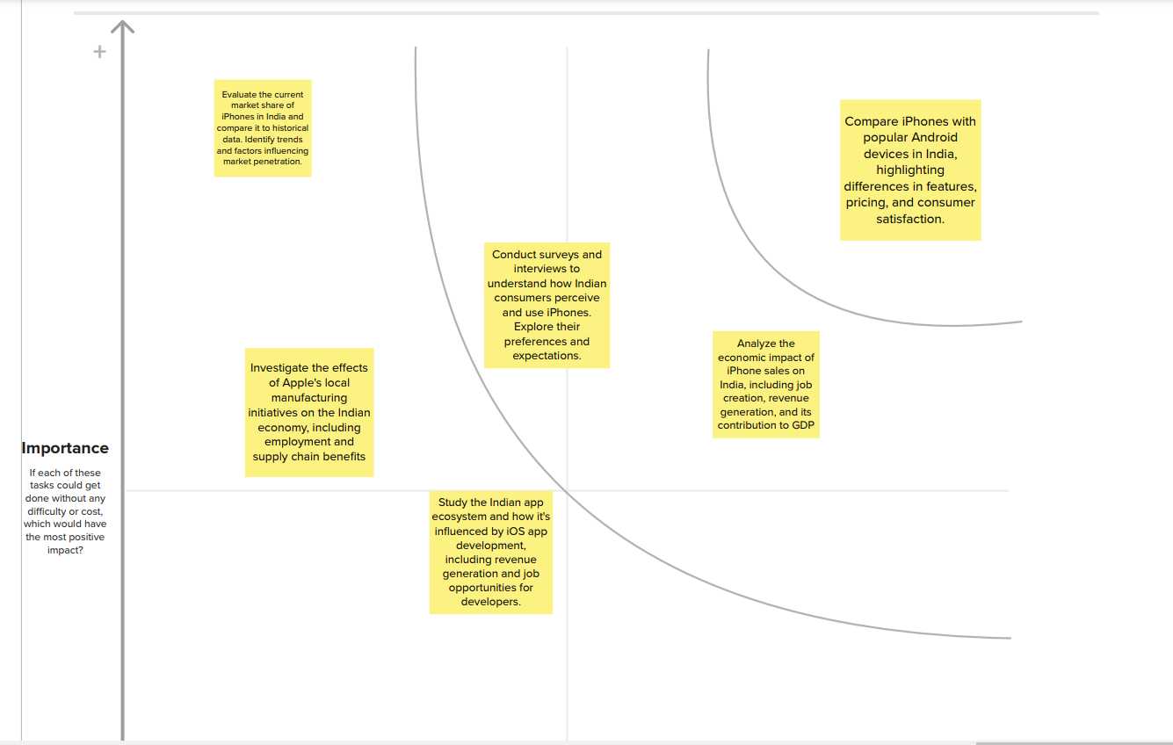

**4. REQUIREMENT ANALYSIS**

**4.1 FUNCTIONAL REQUIREMENTS**

**1. Data Collection and Analysis:** The first requirement for iRevolution is to collect and analyze data related to the impact of Apple's iPhone in the Indian market. This would involve gathering data from various sources such as market research reports, government databases, industry experts, and surveys.

**2. Market Share Analysis:** iRevolution should conduct a thorough analysis of Apple's market share in India, comparing it with other smartphone brands. This analysis should also include a breakdown of market share by different iPhone models and their popularity among different consumer segments.

**3. Consumer Behavior Study**: To understand the impact of iPhone on Indian consumers, iRevolution should conduct a study on consumer behavior towards the brand. This would involve analyzing factors such as purchase patterns, brand loyalty, and consumer satisfaction.

**4. Economic Implications:** The impact of iPhone in India goes beyond just the smartphone market. iRevolution should also analyze the economic implications of iPhone sales, such as its contribution to GDP, employment generation, and foreign investment.

**5. Local Manufacturing Initiatives:** In recent years, Apple has been increasing its focus on local manufacturing in India. iRevolution should study the impact of these initiatives on the Indian economy, job creation, and the overall growth of the smartphone manufacturing industry.

**6. App Ecosystem Growth**: The iPhone has a significant impact on the app ecosystem in India. iRevolution should analyze the growth of the app market, popular categories, and revenue generated through in-app purchases.

**7. Challenges and Opportunities**: iRevolution should identify the challenges faced by Apple in the Indian market, such as competition, pricing, and regulatory barriers. The study should also highlight potential opportunities for growth and expansion in the Indian market.

**8. Recommendations:** Based on the analysis and findings, iRevolution should provide recommendations for Apple to further enhance its impact in the Indian market. These recommendations should be data-driven and backed by insights from the research.

**9. Visualization and Reporting:** iRevolution should present the findings and insights in a visually appealing and easy-to-understand format. This could include charts, graphs, and infographics to help stakeholders better understand the impact of iPhone in India.

**10. Regular Updates:** As the Indian market is constantly evolving, iRevolution should provide regular updates on the impact of iPhone in India. This would help stakeholders stay updated and make informed decisions based on the latest data and insights.

**4.2 NON FUNCTIONAL REQUIREMENTS**

**1. Data Security**: iRevolution should ensure that all data collected and analyzed is secure and protected from unauthorized access or manipulation.

**2. Timeliness:** The data collection and analysis process should be completed in a timely manner to provide up-to-date information on the impact of iPhone in India.

**3. Accuracy:** It is essential for iRevolution to maintain a high level of accuracy in data collection and analysis to ensure the reliability of the findings and recommendations**.**

**4. User-friendly Interface:** The platform used by iRevolution for data visualization and reporting should have a user-friendly interface that is easy to navigate and understand**.**

**5. Scalability:** The platform and tools used by iRevolution should be scalable to accommodate a large amount of data and future updates.

**6. Accessibility:** The platform and reports should be accessible to all stakeholders, including government agencies, industry experts, and the general public.

**7. Confidentiality**: iRevolution should maintain the confidentiality of all data collected and analyzed, adhering to ethical standards and privacy laws.

**8. Collaboration:** The platform used by iRevolution should allow for collaboration among team members to facilitate efficient data collection, analysis, and reporting**.**

**9. Technical Support:** iRevolution should have a dedicated technical support team to assist with any technical issues that may arise during the data collection and analysis process.

**10. Cost-effectiveness:** The tools and resources used by iRevolution should be cost-effective, ensuring that the project remains within budget constraints.

# 5.PROJECT DESIGN

# 5.1Data flow diagram

A Data Flow Diagram (DFD) is a traditional visual representation of the information flows within a system. A neat and clear DFD can depict the right amount of the system requirement graphically. It shows how data enters and leaves the system, what changes the information, and where data is stored.

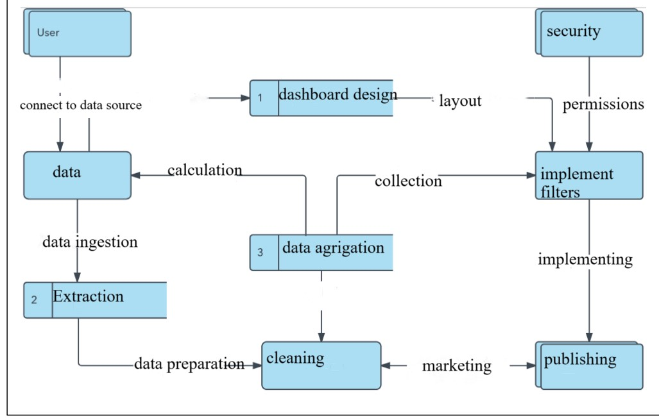**User Stories**

|  |  |  |  |  |  |
| --- | --- | --- | --- | --- | --- |
| **User Type** | **Functional Requirement**  **(Epic)** | **Task** | **Acceptance criteria** | **Priority** | **Team Member** |
| Customer (Web user) | Registration | As a user, I can register for the application by entering my email, password, and confirming my  password. | I can access my account / dashboard | High | Vamsi |
|  |  | As a user, I will receive confirmation email once I have  registered for the application | I can receive confirmation email  & click confirm | Low | Anvesh |
|  |  | As a user, I can register for the application through Google | I can register & access the dashboard with Google Login | High | Venkata Sai |
|  |  | As a user, I can register for the application through Gmail |  | Medium | Ravi kanth |
|  | Login | As a user, I can log into the application by entering email & password |  | High | Venkata Sai |
|  | Dashboard | All the operation which the portal can perform | Once login Customer can view  dashboard |  |  |
| Customer (Web user) | Login & Dashboard |  |  |  |  |
| Customer Care  Executive | View number in dashboard | By sending the query or problem through mail agent we send a  reply |  | medium | Anvesh |
| Administrator |  | Agent from the team will perform the administrative duties |  |  |  |

* 1. **Solution Architecture**

The Tableau solution architecture encompasses a holistic framework designed to meet specific business needs through effective data visualization and analytics. Beginning with a clear understanding of business requirements, the architecture identifies data sources and integrates them into Tableau, employing data modeling and preparation techniques for optimal visualization. Deployment considerations include infrastructure choices, while security measures ensure data integrity and controlled access**.**

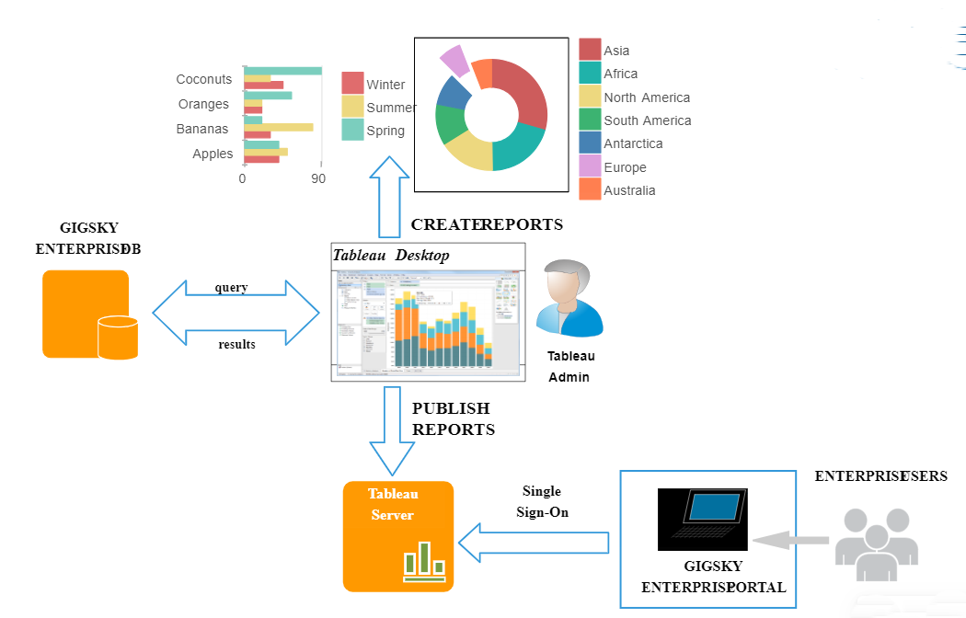

**`6. PROJECT PLANNING & SCHEDULING**

**6.1 TECHNICAL ARCHITECTURE**

Technical architecture for Tableau involves several crucial components and considerations. First and foremost, it's essential to have well-organized and optimized data sources, which can range from databases to cloud platforms and spreadsheets. For larger-scale or complex environments, a data warehouse like Amazon Redshift or Google BigQuery can be employed to enhance query performance. Implementing Extract, Transform, Load (ETL) processes is pivotal for cleaning, transforming, and aggregating data before it's used in Tableau. Tools like Tableau Prep or other ETL solutions can be invaluable for this purpose. Tableau Server or Tableau Online serves as the hosting platform, with Server being on-premises and Online in the cloud

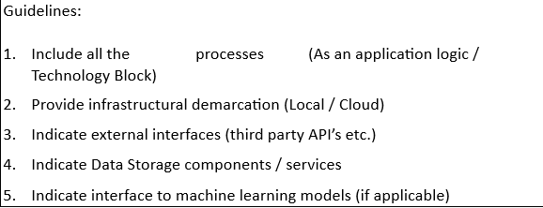

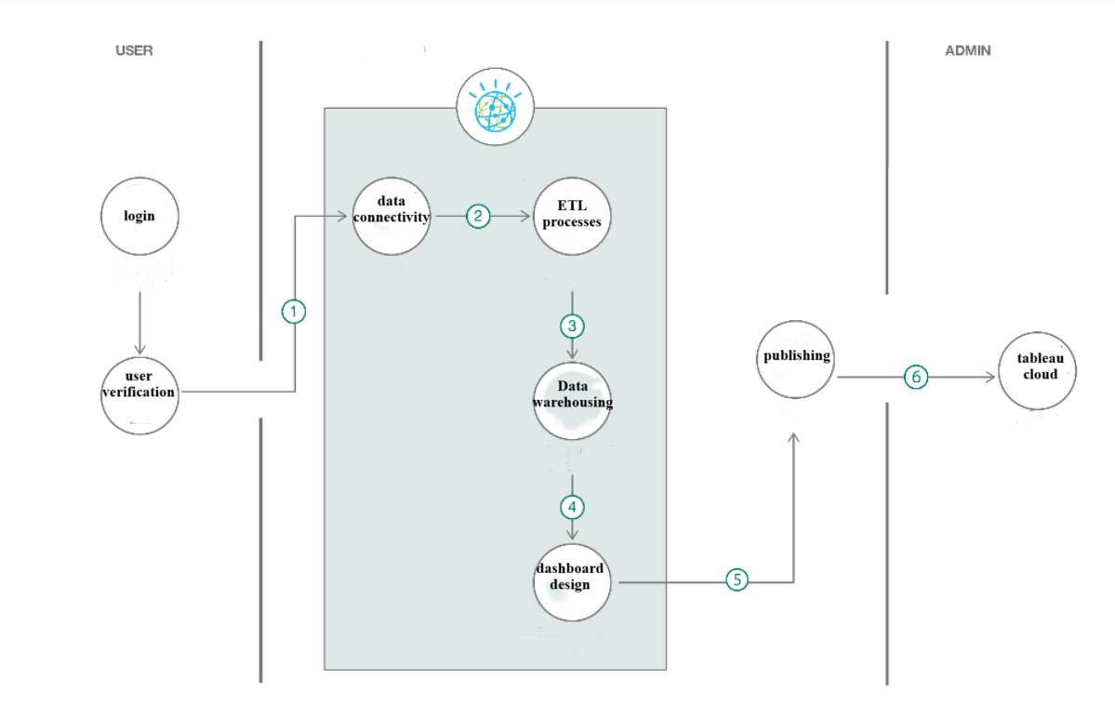

**TABLE – 1 : COMPONENTS AND TECHNOLOGIES**

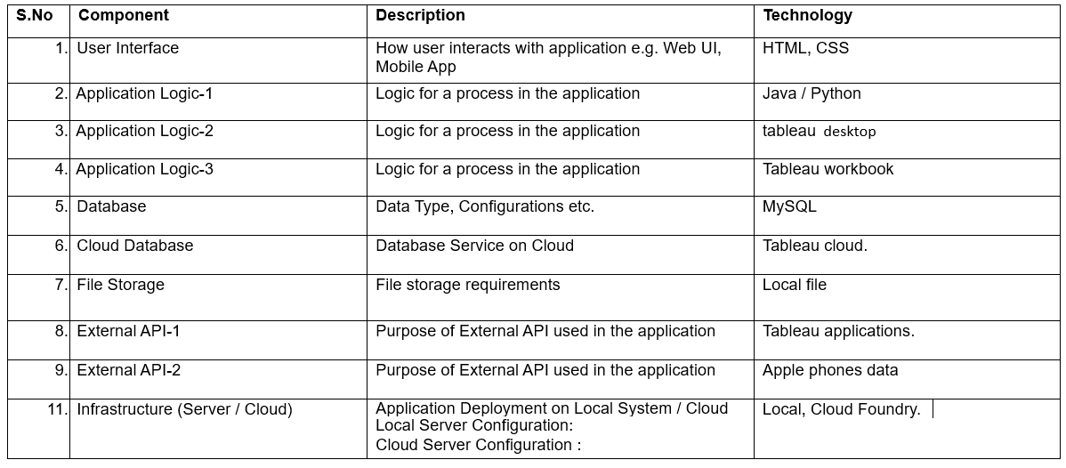

**TABLE-2: Application Characteristics**

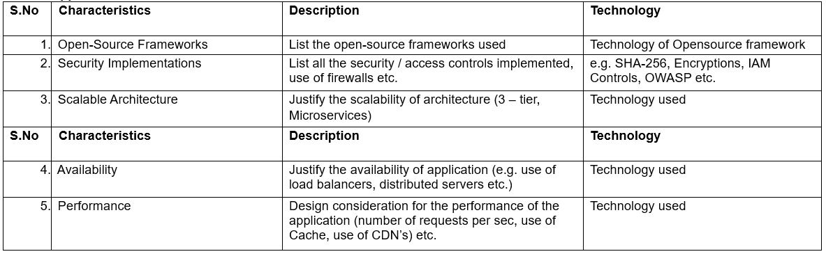

7. **CODING & SOLUTIONING (Explain the features added in the project along with code)**

**DASHBOARD -1 :**

<div class='tableauPlaceholder'

id='viz1697137559569' style='position: relative'>

<noscript>

<a href='#'><img alt='Dashboard 1 ' src='https:&#47;&#47;public.tableau.com&#47;static&#47;images&#47;iR&#47;iRevolutionNM2023TMID02393&#47;Dashboard1&#47;1_rss.png' style='border: none' /></a>

</noscript><object class='tableauViz'  style='display:none;'>

<param name='host_url' value='https%3A%2F%2Fpublic.tableau.com%2F' />

<param name='embed_code_version' value='3' /> <param name='site_root' value='' />

<param name='name' value='iRevolutionNM2023TMID02393&#47;Dashboard1' />

<param name='tabs' value='no' /><param name='toolbar' value='yes' /><param name='static_image' value='https:&#47;&#47;public.tableau.com&#47;static&#47;images&#47;iR&#47;iRevolutionNM2023TMID02393&#47;Dashboard1&#47;1.png' />

<param name='animate_transition' value='yes' /><param name='display_static_image' value='yes' /><param name='display_spinner' value='yes' /><param name='display_overlay' value='yes' /><param name='display_count' value='yes' /><param name='language' value='en-US' /></object></div>                <script type='text/javascript'>                    var divElement = document.getElementById('viz1697137559569');                    var vizElement = divElement.getElementsByTagName('object')[0];                    if ( divElement.offsetWidth > 800 ) { vizElement.style.width='1000px';vizElement.style.height='827px';} else if ( divElement.offsetWidth > 500 ) { vizElement.style.width='1000px';vizElement.style.height='827px';} else { vizElement.style.width='100%';vizElement.style.height='1627px';}                     var scriptElement = document.createElement('script');                    scriptElement.src = 'https://public.tableau.com/javascripts/api/viz_v1.js';                    vizElement.parentNode.insertBefore(scriptElement, vizElement);

 </script>

**DASHBOARD – 2**

div class='tableauPlaceholder' id='viz1697137647746' style='position: relative'><noscript><a href='#'><img alt='Dashboard 2 ' src='https:&#47;&#47;public.tableau.com&#47;static&#47;images&#47;iR&#47;iRevolutionNM2023TMID02393D2&#47;Dashboard2&#47;1_rss.png' style='border: none' /></a></noscript><object class='tableauViz'  style='display:none;'><param name='host_url' value='https%3A%2F%2Fpublic.tableau.com%2F' /> <param name='embed_code_version' value='3' /> <param name='site_root' value='' /><param name='name' value='iRevolutionNM2023TMID02393D2&#47;Dashboard2' /><param name='tabs' value='no' /><param name='toolbar' value='yes' /><param name='static_image' value='https:&#47;&#47;public.tableau.com&#47;static&#47;images&#47;iR&#47;iRevolutionNM2023TMID02393D2&#47;Dashboard2&#47;1.png' /> <param name='animate_transition' value='yes' /><param name='display_static_image' value='yes' /><param name='display_spinner' value='yes' /><param name='display_overlay' value='yes' /><param name='display_count' value='yes' /><param name='language' value='en-US' /></object></div>                <script type='text/javascript'>                    var divElement = document.getElementById('viz1697137647746');                    var vizElement = divElement.getElementsByTagName('object')[0];                    if ( divElement.offsetWidth > 800 ) { vizElement.style.width='1000px';vizElement.style.height='827px';} else if ( divElement.offsetWidth > 500 ) { vizElement.style.width='1000px';vizElement.style.height='827px';} else { vizElement.style.width='100%';vizElement.style.height='2027px';}                     var scriptElement = document.createElement('script');                    scriptElement.src = 'https://public.tableau.com/javascripts/api/viz_v1.js';                    vizElement.parentNode.insertBefore(scriptElement, vizElement);                </script>

**STORY**

<div class='tableauPlaceholder' id='viz1697138515735' style='position: relative'><noscript><a href='#'><img alt='Story 1 ' src='https:&#47;&#47;public.tableau.com&#47;static&#47;images&#47;iR&#47;iRevolutionNM2023TMID02393S&#47;Story1&#47;1_rss.png' style='border: none' /></a></noscript><object class='tableauViz'  style='display:none;'><param name='host_url' value='https%3A%2F%2Fpublic.tableau.com%2F' /> <param name='embed_code_version' value='3' /> <param name='site_root' value='' /><param name='name' value='iRevolutionNM2023TMID02393S&#47;Story1' /><param name='tabs' value='no' /><param name='toolbar' value='yes' /><param name='static_image' value='https:&#47;&#47;public.tableau.com&#47;static&#47;images&#47;iR&#47;iRevolutionNM2023TMID02393S&#47;Story1&#47;1.png' /> <param name='animate_transition' value='yes' /><param name='display_static_image' value='yes' /><param name='display_spinner' value='yes' /><param name='display_overlay' value='yes' /><param name='display_count' value='yes' /><param name='language' value='en-US' /></object></div>                <script type='text/javascript'>                    var divElement = document.getElementById('viz1697138515735');                    var vizElement = divElement.getElementsByTagName('object')[0];                    vizElement.style.width='1016px';vizElement.style.height='991px';                    var scriptElement = document.createElement('script');                    scriptElement.src = 'https://public.tableau.com/javascripts/api/viz_v1.js';                    vizElement.parentNode.insertBefore(scriptElement, vizElement);

       </script>

**8. PERFORMANCE TESTING**

|  |  |  |
| --- | --- | --- |
| **SI.NO :** | P**ARAMETER** | **SCREENSHOTS\VALUES** |
| 1 | DASHBOARD DESIGN |  |
| 2 | DATA RESPONIVENESS |  |
| 3 | Amount data to rendered |  |
| 4 | Utilization of data filters |  |
| 5 | Effective use of Story |  |
| 6 | Descriptive report |  |

**9.RESULTS**

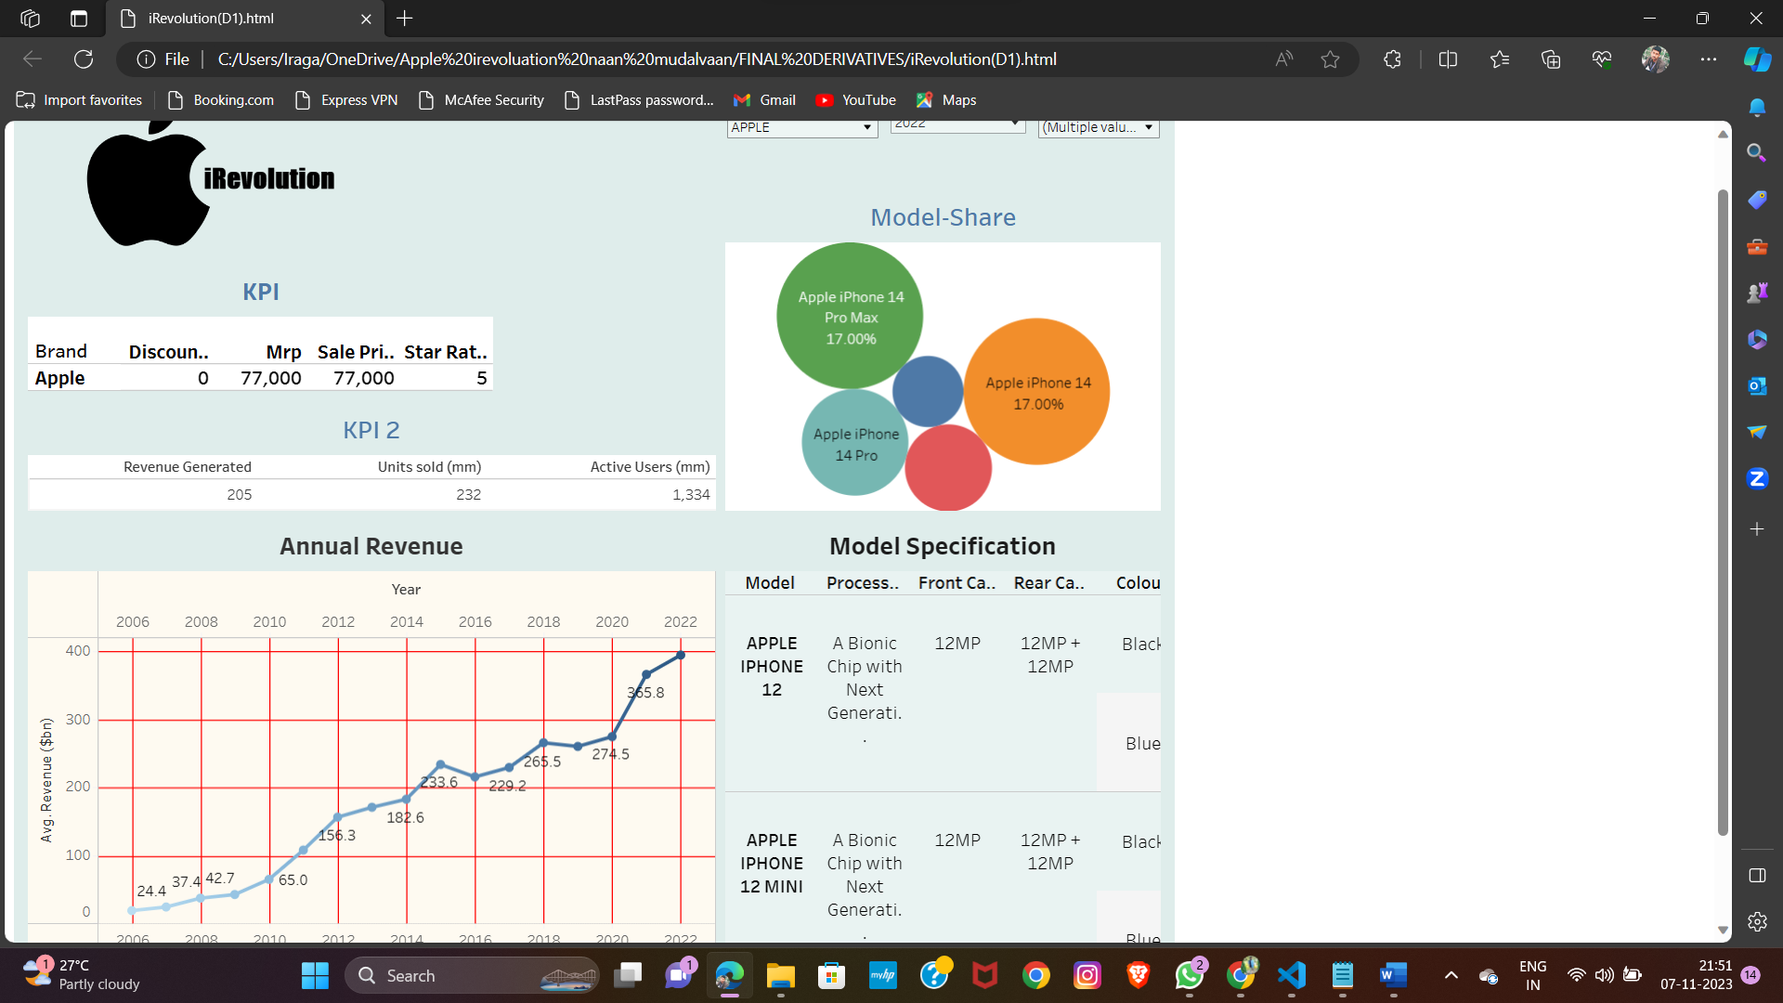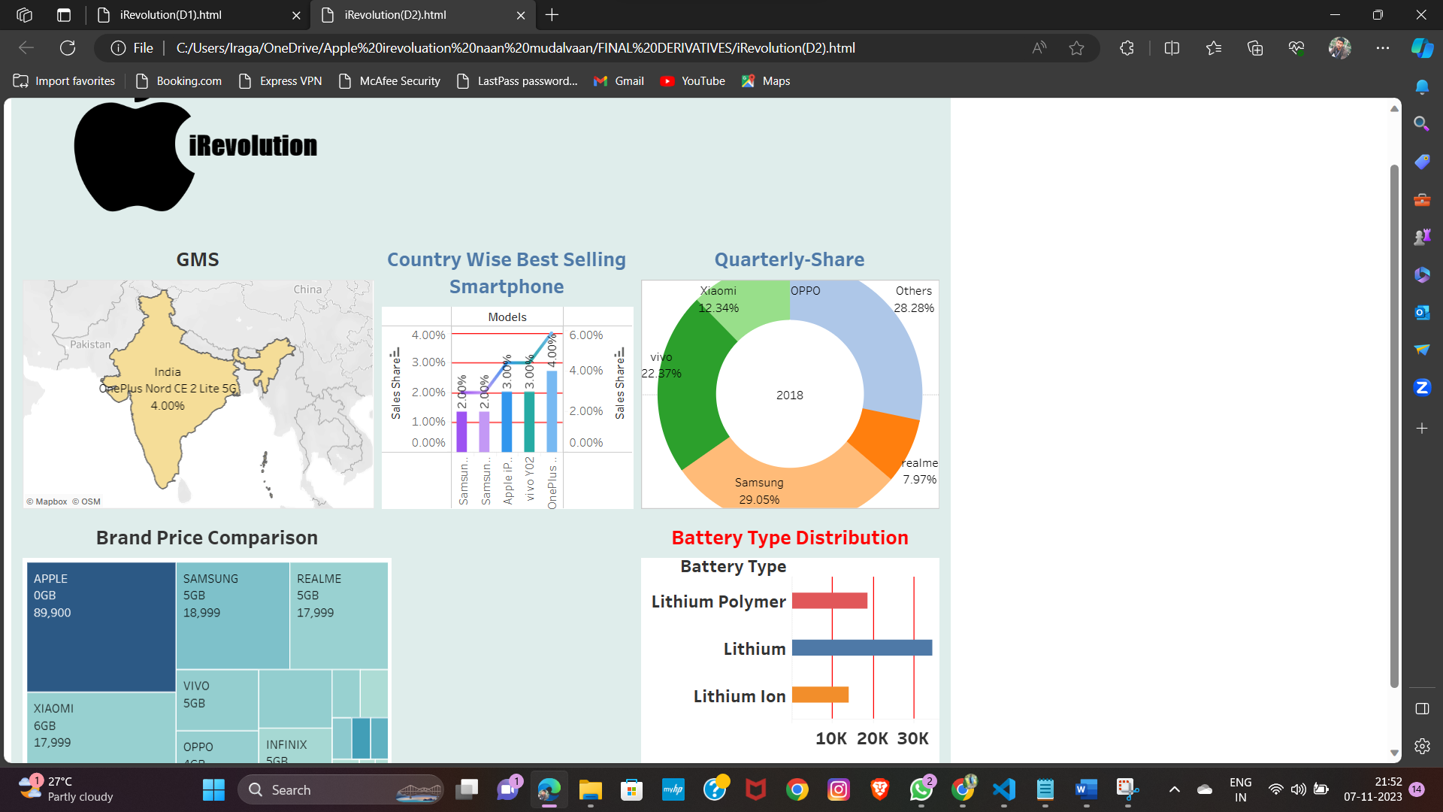

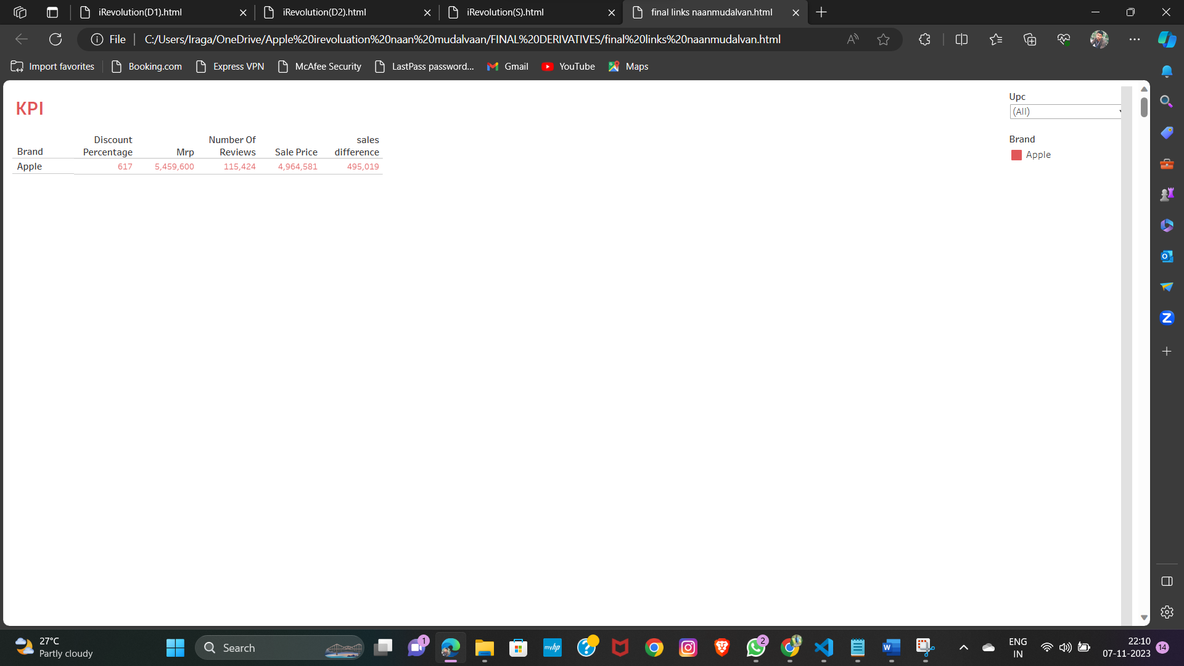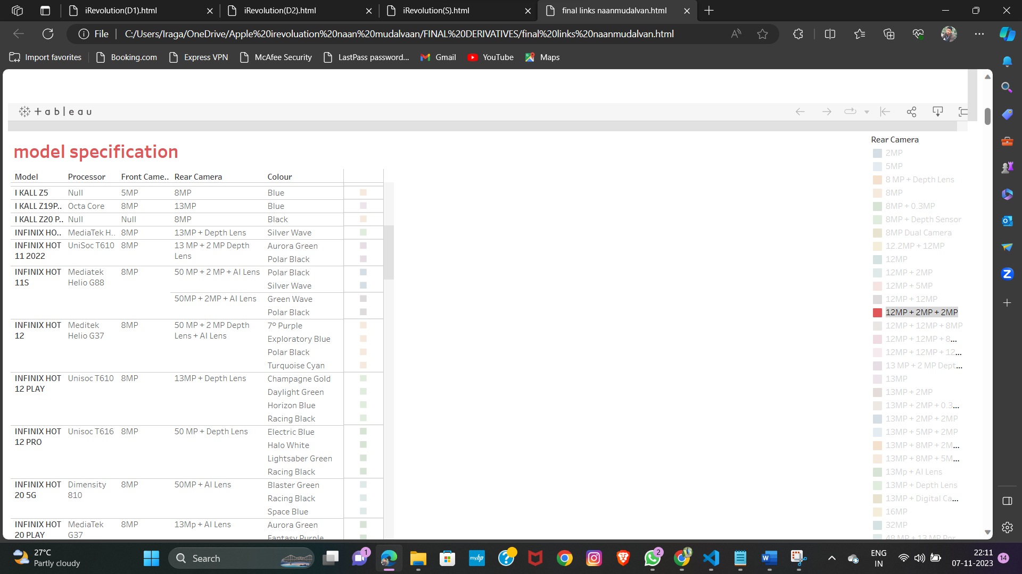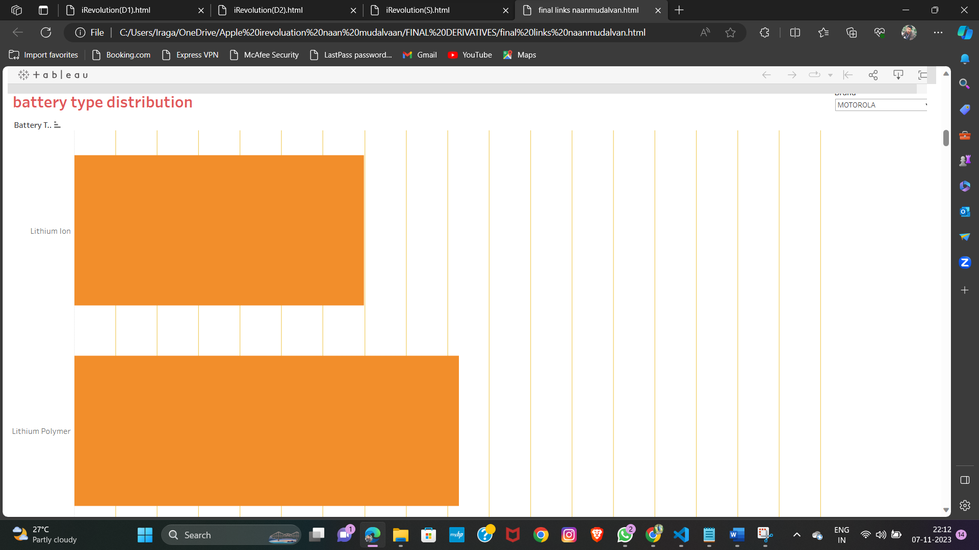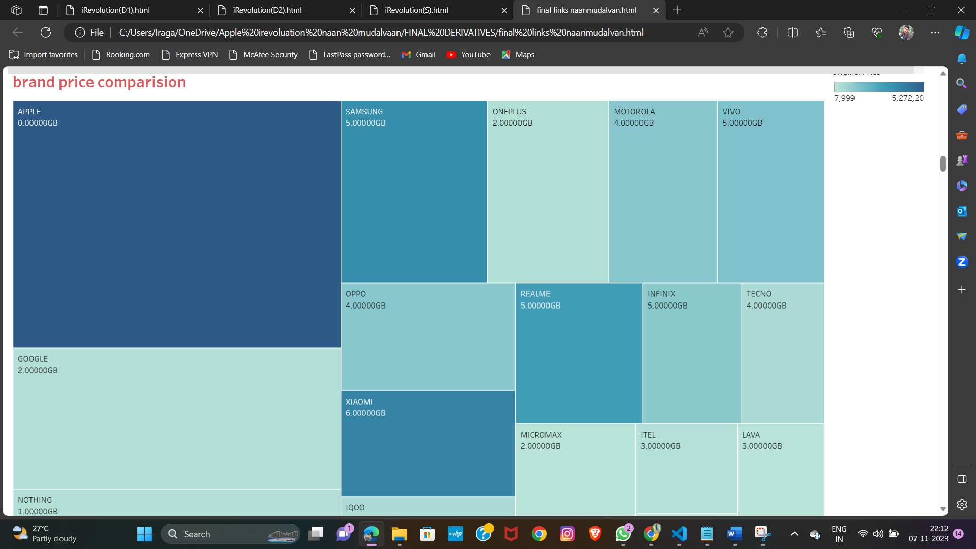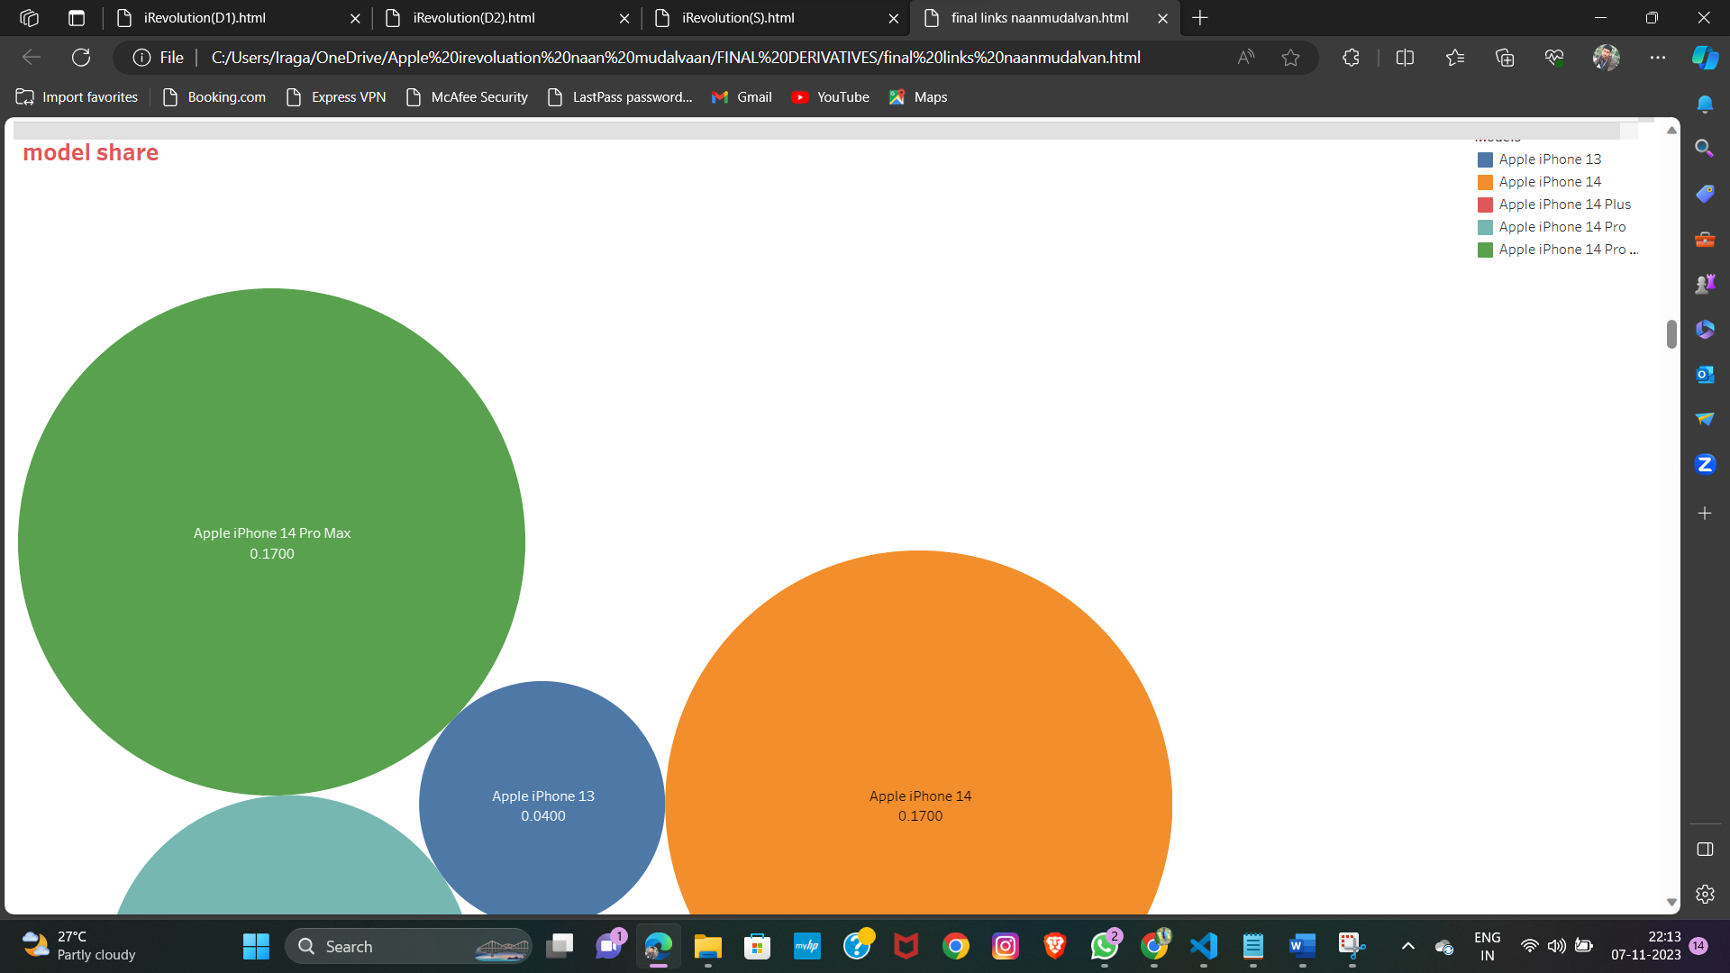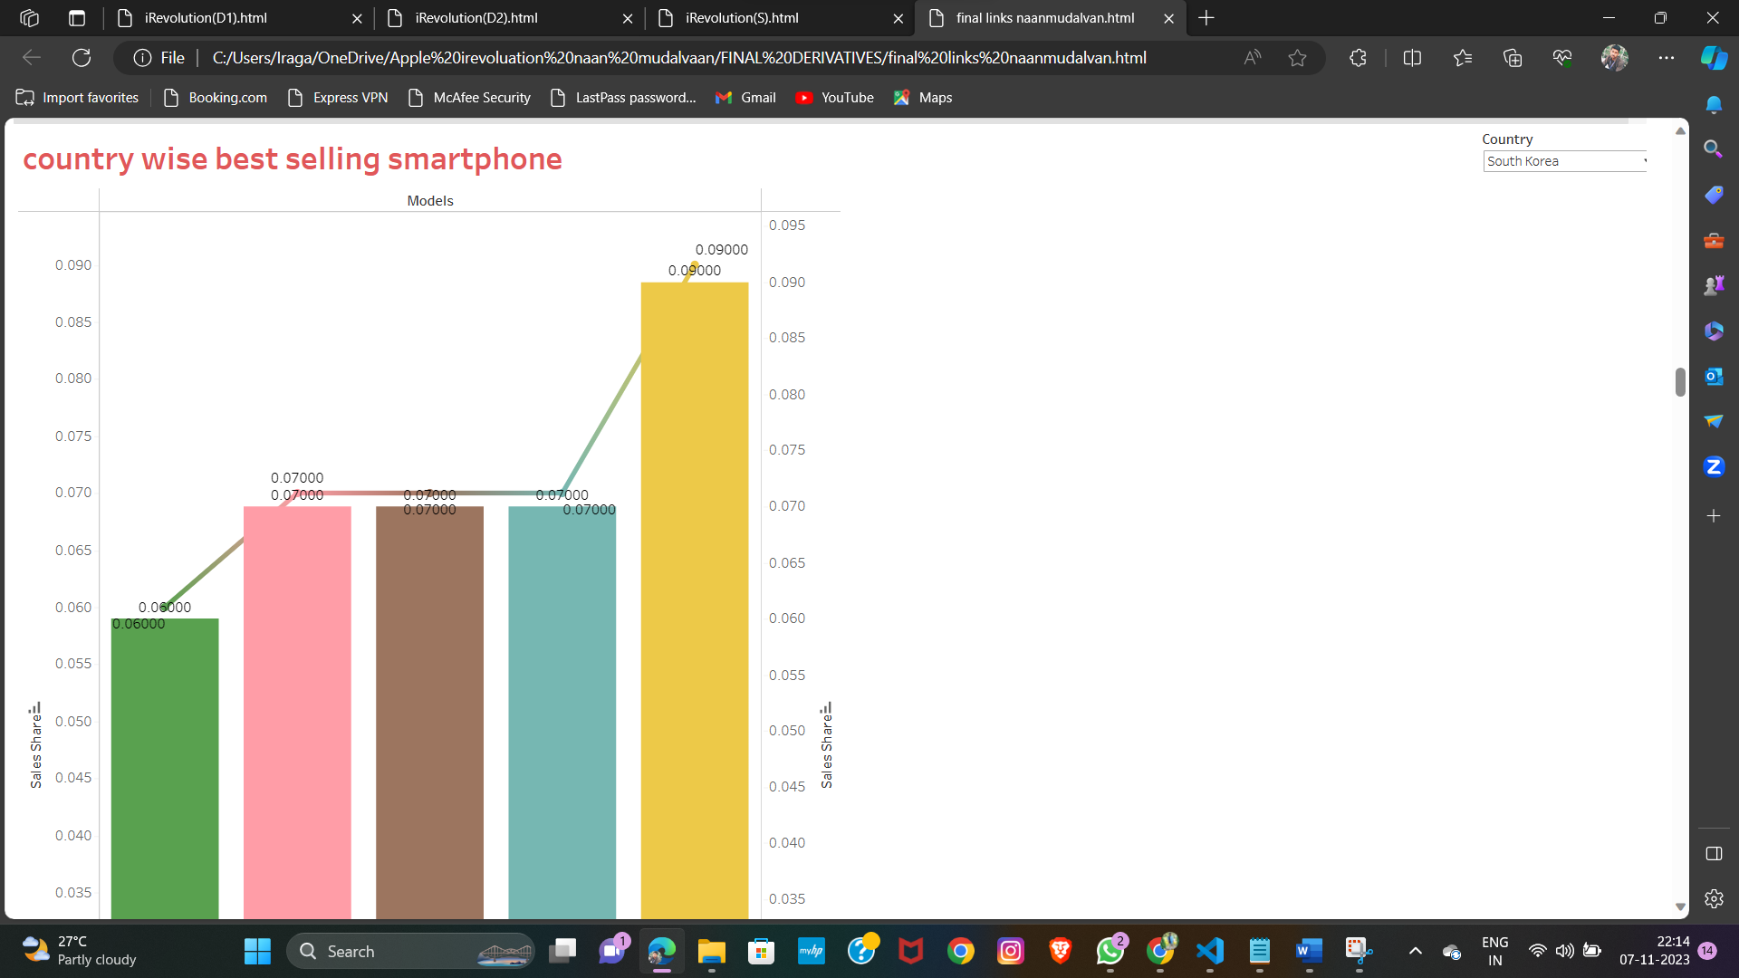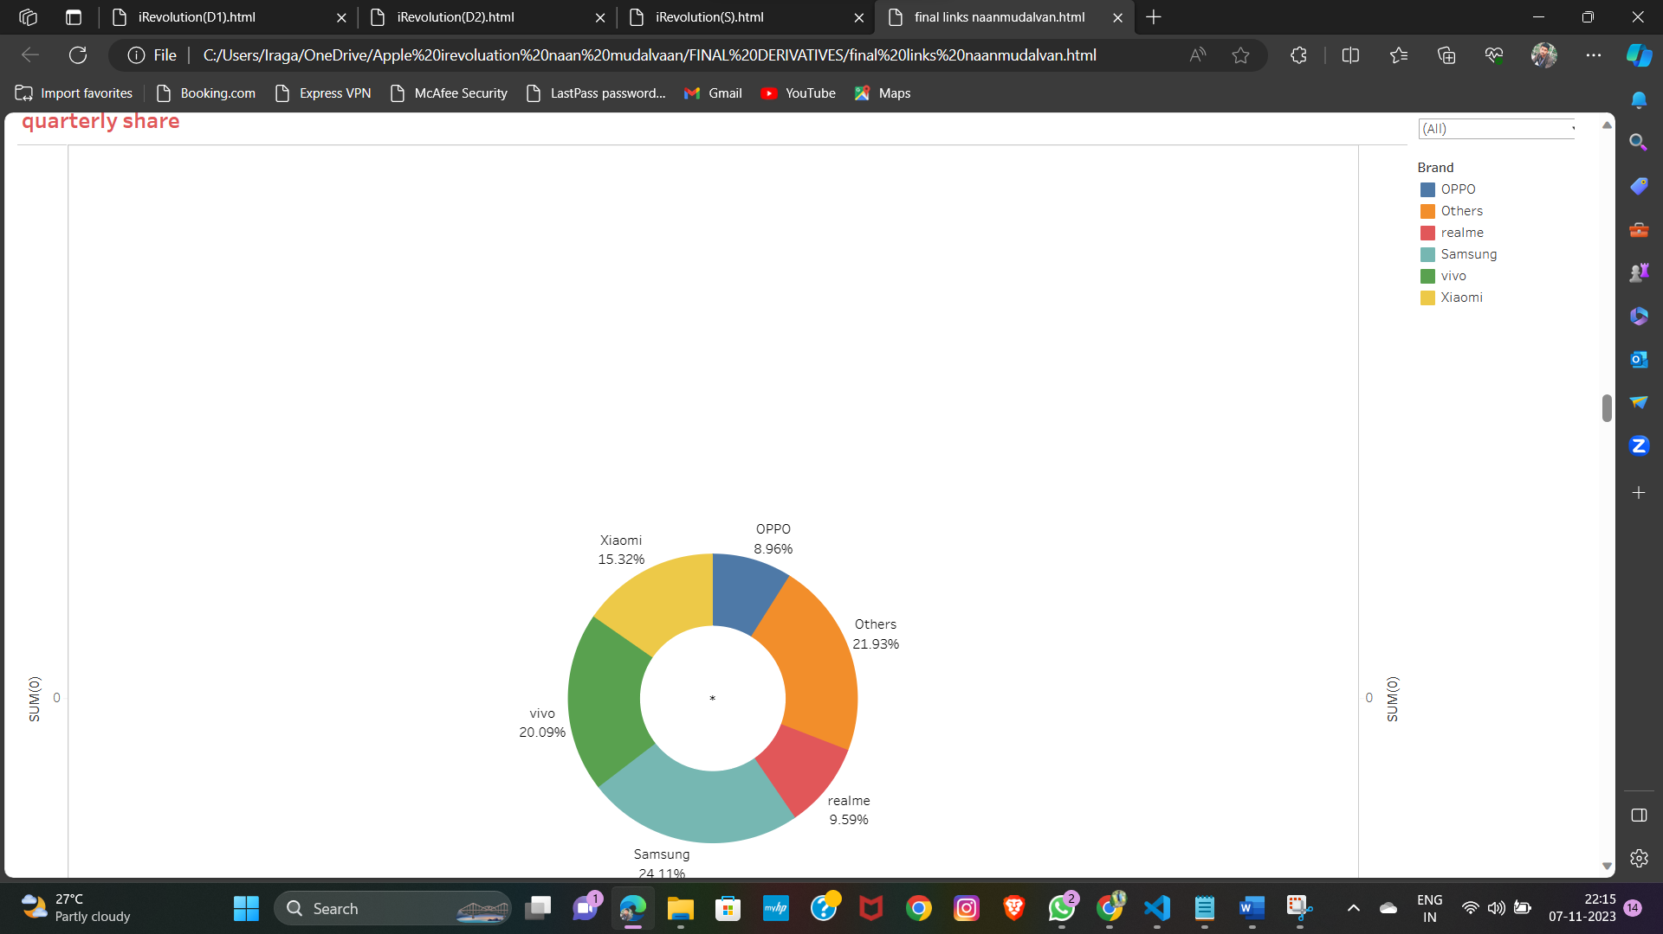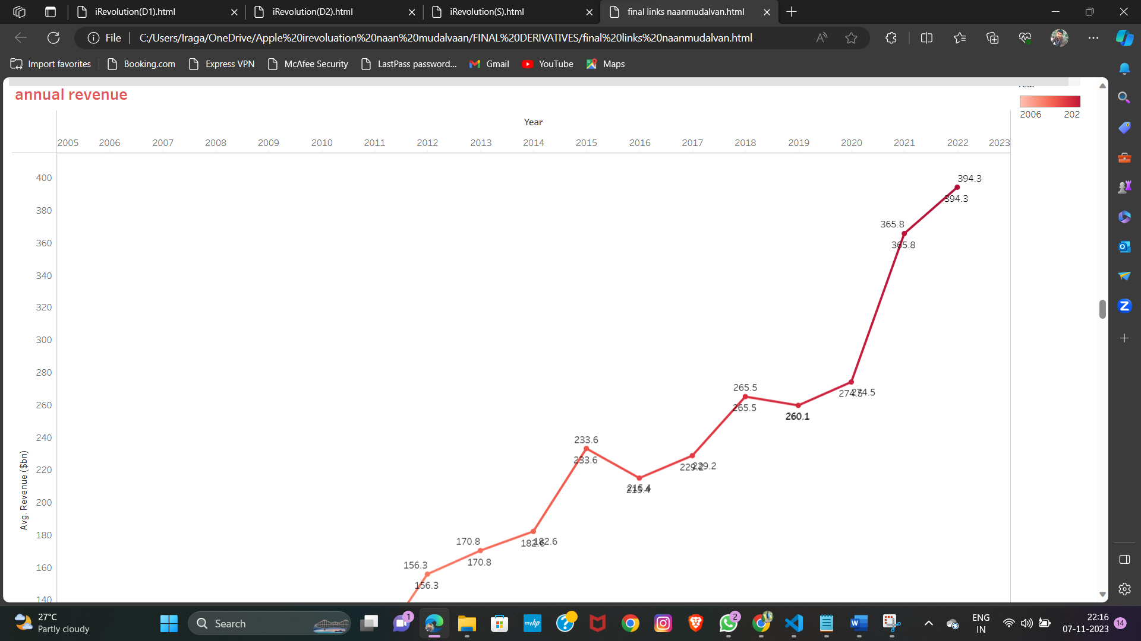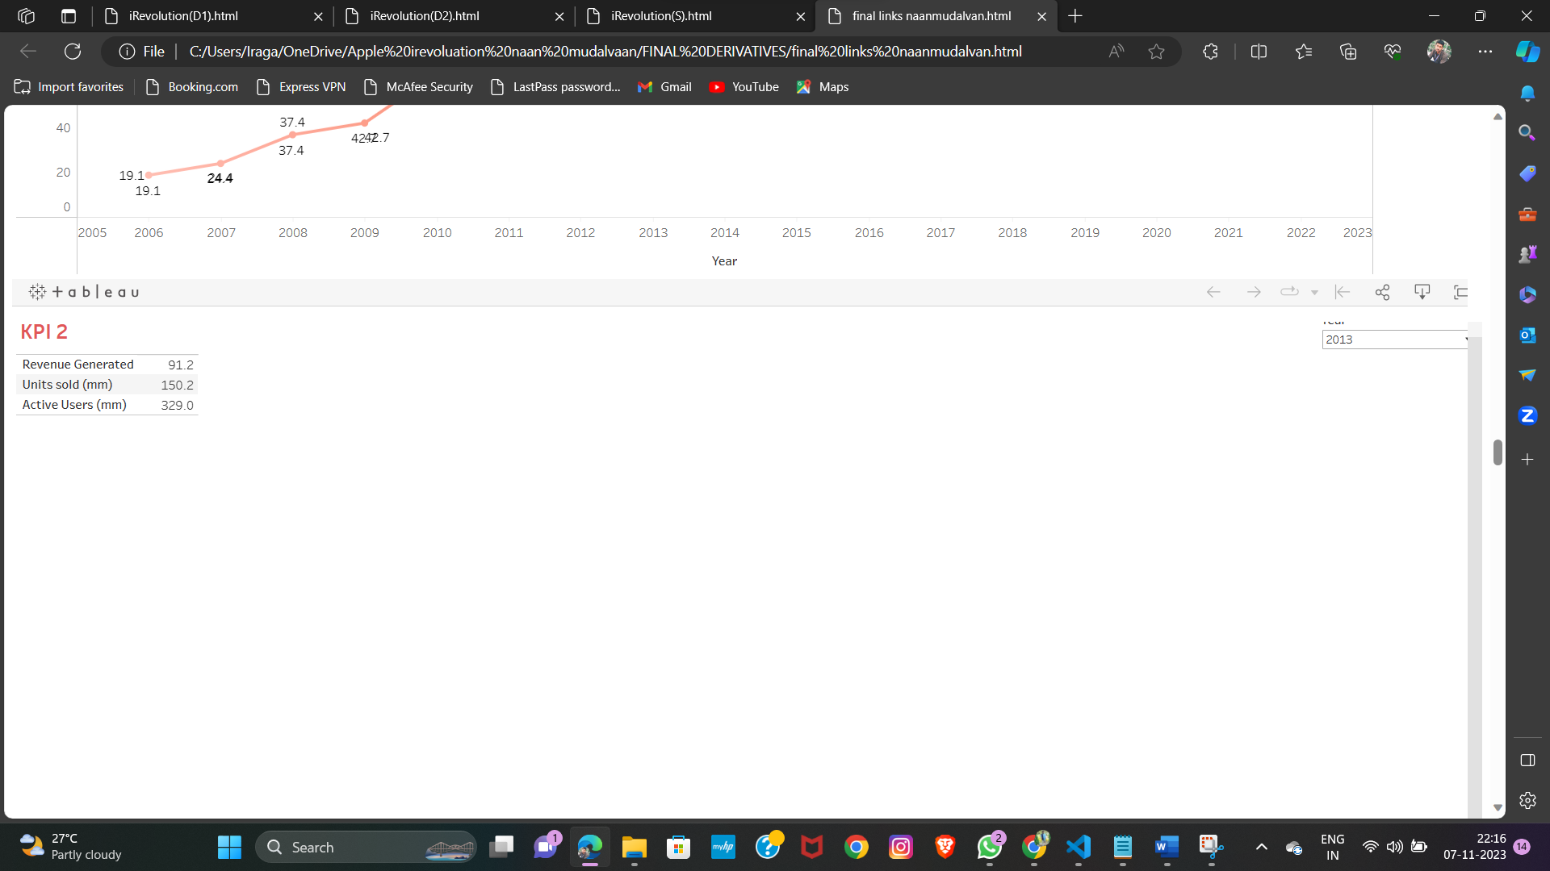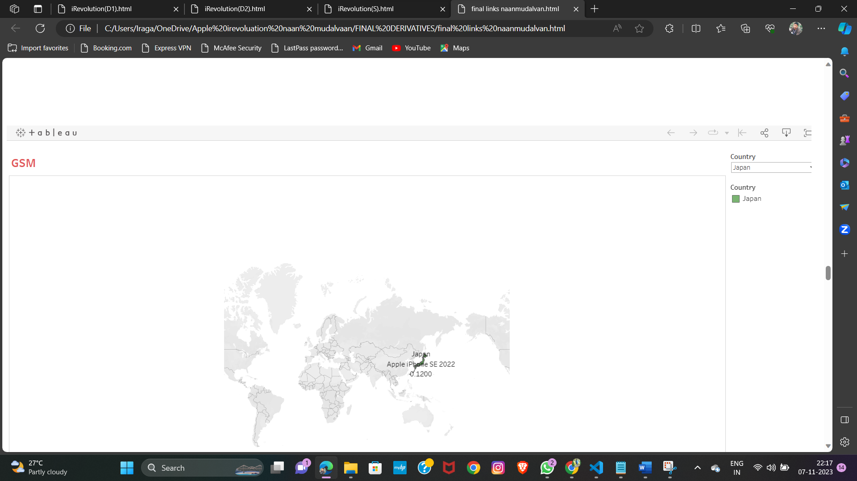

**10.ADVANTAGES & DISADANTAGES**

**ADVANTAGES**

|  |
| --- |
|  |
| * Apple has a special chance to increase its market share and develop a significant presence in India thanks to the countrys large population and rising smartphone adoption. * Impressive compensation, benefits and overall earning potential. * By using the iPod for 2 or 3 years, most users would want to choose an iPhone over other smartphone brands. * Enhancing Citizen Engagement Technology has played a pivotal role in transforming governance by enhancing citizen engagement. |
|  |

**DISADVANTAGES**

* Apple has made a practice of crediting machine learning with boosting specific functions in the iPhone, Apple Watch, or iPad, but it seldom goes into much detail.
* Each new iPhone model unveiling generates excitement and anticipation among Indian buyers.
* The iPhone has generated large profits for Apple, making it one of the worlds most valuable publicly traded companies.
* The capacity of Apple to retain and satisfy users inside its ecosystem is at the heart of its sustained success.
* Qualitative observation is often also used in design fields, to better understand user needs, preferences, and behaviors.
* Since smartphones are the most commonly used handheld devices, after Android, iOS is the second most used mobile operating system.
* Since the late 2010s, smartphone manufacturers have bypassed the lack of optical zoom to a limited extent by incorporating additional rear cameras with fixed magnification levels.

**10.CONCLUSION**

In conclusion, the data-driven exploration of Apple's iPhone impact in India reveals several key findings. Firstly, the iPhone has experienced significant growth in the Indian market over the past decade, becoming a highly sought-after device among consumers. The availability of affordable models and financing options has played a crucial role in driving this adoption. Secondly, Apple's investment in localized manufacturing and retail expansion has further bolstered its presence in India. This strategy has not only created job opportunities but also strengthened the brand's relationship with Indian customers. Furthermore, data indicates that iPhone users in India exhibit strong brand loyalty and are willing to spend more on apps and services. This highlights Apple's potential to tap into India's growing digital economy

**11.FUTURE SCOPE**

As Apple continues to expand its presence in the Indian market, there are several key predictions and recommendations for the future growth of iPhones in India. Firstly, with the increasing affordability of smartphones and rising disposable income, it is expected that more Indian consumers will opt for premium devices like iPhones. To tap into this potential, Apple should focus on developing localized marketing strategies tailored to Indian consumers' preferences and needs. Additionally, there is a significant opportunity for Apple to further penetrate the Indian market by expanding its retail presence beyond major cities. This can be achieved through partnerships with local retailers or establishing flagship stores in prominent locations.

**DEMO VIDEO LINK** –

<https://drive.google.com/file/d/1lWdKO0ynifOyhAvjzvjuhmmCLjh3Nzd/view?usp=drivesdk>

**GITHUB LINK:**

[**https://github.com/venkatasaireddy1234/iRevolution-A-Data-driven-Exploration-of-Apple-s-iPhone-Impact-in-India./upload/main**](https://github.com/venkatasaireddy1234/iRevolution-A-Data-driven-Exploration-of-Apple-s-iPhone-Impact-in-India./upload/main)